- Draw the Network Security Model and explain it.
A message is to be transferred from one party to another across some sort of Internet service. The two parties, who are the principals in this transaction, must cooperate for the exchange to take place. A logical information channel is established by defining a route through the Internet from source to destination and by the cooperative use of communication protocols (e.g., TCP/IP) by the two principals.
Security aspects come into play when it is necessary or desirable to protect the information transmission from an opponent who may present a threat to confidentiality, authenticity, and so on. All the techniques for providing security have two components:
■ A security-related transformation on the information to be sent. Examples include the encryption of the message, which scrambles the message so that it is unreadable by the opponent, and the addition of a code based on the contents of the message, which can be used to verify the identity of the sender.
■ Some secret information shared by the two principals and, it is hoped, unknown to the opponent. An example is an encryption key used in conjunction with the transformation to scramble the message before transmission and unscramble it on reception.
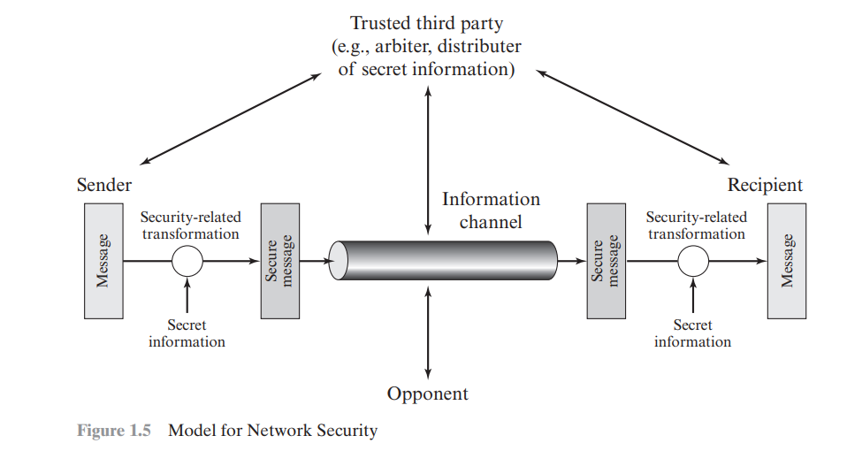
A trusted third party may be needed to achieve secure transmission. For example, a third party may be responsible for distributing the secret information to the two principals while keeping it from any opponent. Or a third party may be needed to arbitrate disputes between the two principals concerning the authenticity of a message transmission.
This general model shows that there are four basic tasks in designing a particular security service:
1. Design an algorithm for performing the security-related transformation. The algorithm should be such that an opponent cannot defeat its purpose.
2. Generate the secret information to be used with the algorithm.
3. Develop methods for the distribution and sharing of the secret information.
4. Specify a protocol to be used by the two principals that makes use of the security algorithm and the secret information to achieve a particular security service.
- Explain DES construction in detail with a neat diagram
Until the introduction of the Advanced Encryption Standard (AES) in 2001, the Data Encryption Standard (DES) was the most widely used encryption scheme. DES was issued in 1977 by the National Bureau of Standards, now the National Institute of Standards and Technology (NIST), as Federal Information Processing Standard 46 (FIPS PUB 46)
The algorithm itself is referred to as the Data Encryption Algorithm (DEA).For DEA, data are encrypted in 64-bit blocks using a 56-bit key. The algorithm transforms 64-bit input in a series of steps into a 64-bit output. The same steps, with the same key, are used to reverse the encryption.
The overall scheme for DES encryption is illustrated in Figure. As with any encryption scheme, there are two inputs to the encryption function: the plaintext to be encrypted and the key. In this case, the plaintext must be 64 bits in length and the key is 56 bits in length.
Looking at the left-hand side of the figure, we can see that the processing of the plaintext proceeds in three phases. First, the 64-bit plaintext passes through an initial permutation (IP) that rearranges the bits to produce the permuted input.
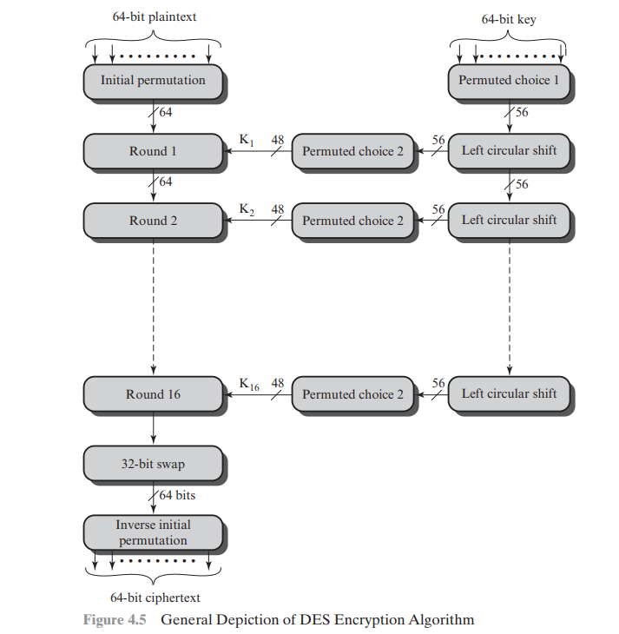
This is followed by a phase consisting of sixteen rounds of the same function, which involves both permutation and substitution functions. The output of the last (sixteenth) round consists of 64 bits that are a function of the input plaintext and the key. The left and right halves of the output are swapped to produce the preoutput. Finally, the preoutput is passed through a permutation [IP-1 ] that is the inverse of the initial permutation function, to produce the 64-bit ciphertext. With the exception of the initial and final permutations, DES has the exact structure of a Feistel cipher.
The right-hand portion of Figure 4.5 shows the way in which the 56-bit key is used. Initially, the key is passed through a permutation function. Then, for each of the sixteen rounds, a subkey (Ki ) is produced by the combination of a left circular shift and a permutation. The permutation function is the same for each round, but a different subkey is produced because of the repeated shifts of the key bits.
- Explain Ceaser Cipher with example
The earliest known, and the simplest, use of a substitution cipher was by Julius Caesar. The Caesar cipher involves replacing each letter of the alphabet with the letter standing three places further down the alphabet. For example,
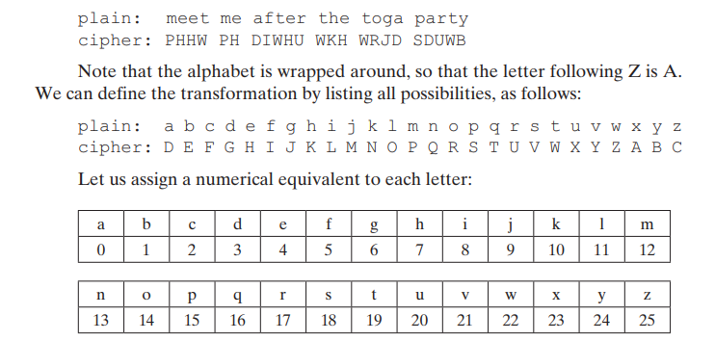
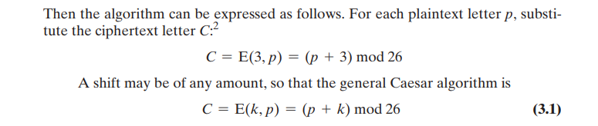
where k takes on a value in the range 1 to 25. The decryption algorithm is simply
p = D(k, C) = (C - k) mod 26
If it is known that a given ciphertext is a Caesar cipher, then a brute-force cryptanalysis is easily performed: simply try all the 25 possible keys. In this case, the plaintext leaps out as occupying the third line.
Three important characteristics of this problem enabled us to use a bruteforce cryptanalysis:
1. The encryption and decryption algorithms are known.
2. There are only 25 keys to try.
3. The language of the plaintext is known and easily recognizable.
In most networking situations, we can assume that the algorithms are known. What generally makes brute-force cryptanalysis impractical is the use of an algorithm that employs a large number of keys. For example, the triple DES algorithm
- What is the one-time pad technique? List the advantages and disadvantages
The one-time pad is an encryption technique proposed by Joseph Mauborgne as an improvement to the Vernam cipher. In this method, a truly random key is generated that is as long as the message to be encrypted. The key is used only once (for a single message) and then discarded. Each new message requires a new random key of the same length. Since the ciphertext has no statistical relationship with the plaintext, the one-time pad provides perfect secrecy and is theoretically unbreakable.
Advantages
- Provides ultimate security (perfect secrecy) when the key is truly random, used once, and kept secret.
- Ciphertext is completely random and bears no statistical pattern that cryptanalysts can exploit.
- Even with exhaustive search, multiple plausible plaintexts can be produced, making it impossible to know the correct one.
- Resistant to cryptanalysis, as every possible plaintext of the same length is equally likely.
Disadvantages
The one-time pad offers complete security but, in practice, has two fundamental difficulties:
1. There is the practical problem of making large quantities of random keys. Any heavily used system might require millions of random characters on a regular basis. Supplying truly random characters in this volume is a significant task.
2. Even more daunting is the problem of key distribution and protection. For every message to be sent, a key of equal length is needed by both sender and receiver. Thus, a mammoth key distribution problem exists.
Because of these difficulties, the one-time pad is of limited utility and is useful primarily for low-bandwidth channels requiring very high security. The one-time pad is the only cryptosystem that exhibits what is referred to as perfect secrecy.
- List the difference between Conventional and public key encryption.
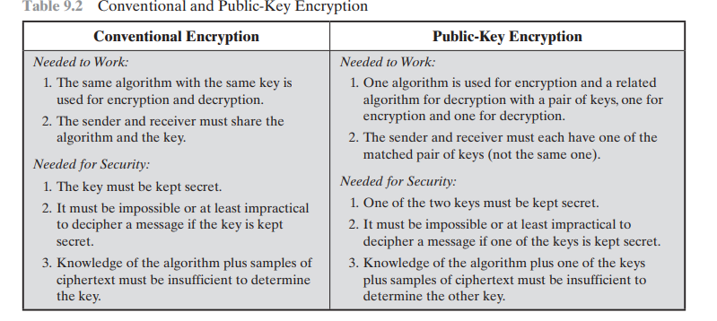
- Explain the public key cryptosystem with a neat diagram.
Asymmetric algorithms rely on one key for encryption and a different but related key for decryption. These algorithms have the following important characteristic.
■ It is computationally infeasible to determine the decryption key given only knowledge of the cryptographic algorithm and the encryption key.
In addition, some algorithms, such as RSA, also exhibit the following characteristic.
■ Either of the two related keys can be used for encryption, with the other used for decryption.
A public-key encryption scheme has six ingredients
■ Plaintext: This is the readable message or data that is fed into the algorithm as input.
■ Encryption algorithm: The encryption algorithm performs various transformations on the plaintext
Public and private keys: This is a pair of keys that have been selected so that if one is used for encryption, the other is used for decryption. The exact transformations performed by the algorithm depend on the public or private key that is provided as input.
Ciphertext: This is the encrypted message produced as output. It depends on the plaintext and the key. For a given message, two different keys will produce two different ciphertexts.
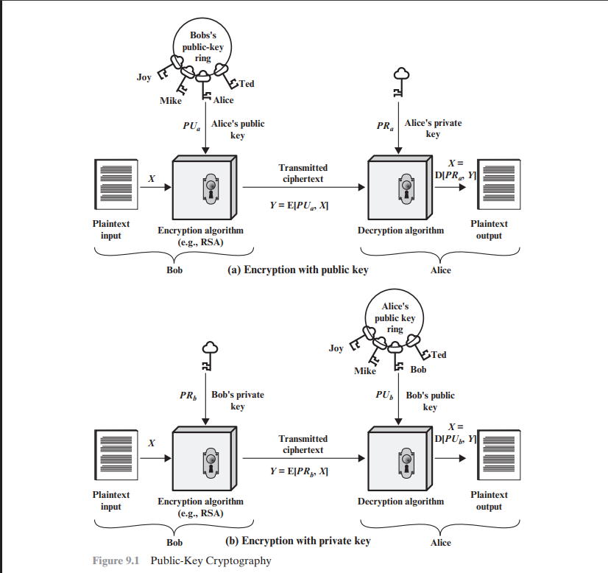

Decryption algorithm: This algorithm accepts the ciphertext and the matching key and produces the original plaintext. The essential steps are the following.
1. Each user generates a pair of keys to be used for the encryption and decryption of messages.
2. Each user places one of the two keys in a public register or other accessible file. This is the public key. The companion key is kept private. As Figure 9.1a suggests, each user maintains a collection of public keys obtained from others.
3. If Bob wishes to send a confidential message to Alice, Bob encrypts the message using Alice’s public key.
4. When Alice receives the message, she decrypts it using her private key. No other recipient can decrypt the message because only Alice knows Alice’s private key.

- With a neat diagram, explain the Man-in-middle Attack
Alice and Bob wish to exchange keys, and Darth is the adversary. The attack proceeds as follows .
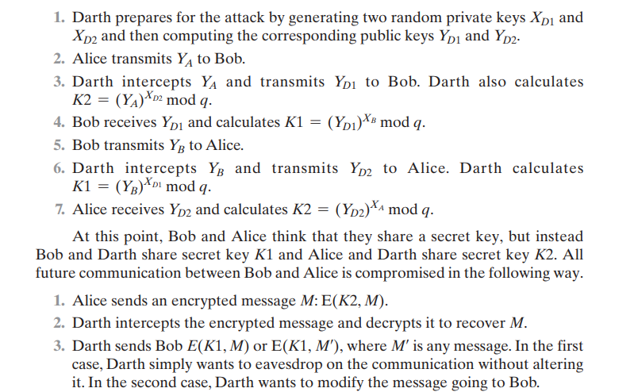
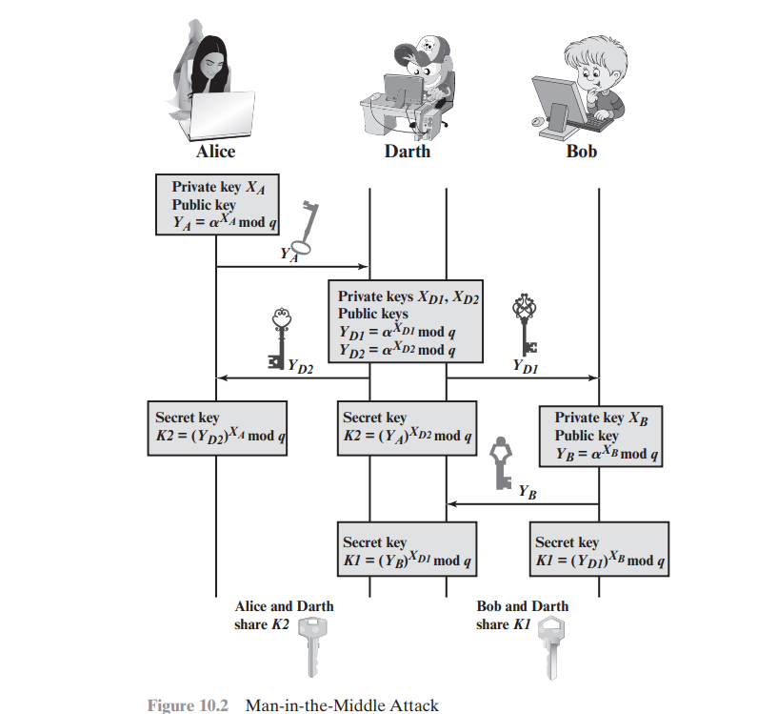
- Explain Playfair Cipher and its rules for the following example: Ex: Keyword: "Computer" Plaintext: "parrot"
The best-known multiple-letter encryption cipher is the Playfair, which treats digrams in the plaintext as single units and translates these units into ciphertext digrams.
The Playfair algorithm is based on the use of a 5 * 5 matrix of letters constructed using a keyword. Here is an example, solved by Lord Peter Wimsey in Dorothy Sayers’s Have His Carcase
